**Curriculum vitae**

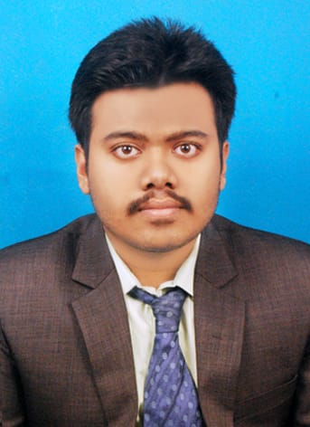

**SOUMIK DHAR**

*(B.Tech in Electronics & Communication Engineering)*

**Address**: 53 /19 Bidyayatan Sarani, kolkata **pin**:700035

**Mobile:** +919748661444/ +917980669721

**E-mail**:[soumikdhar222@gmail.com](mailto:soumikdhar222@gmail.com)

**Github:** <https://github.com/Soumik222>

**Career Objective:**

To be able to work for an encouraging and stable company that will assist me in developing, improving, and obtaining the necessary skills in order to become the best engineer possible. I would like to implement my innovative ideas, skills and creativity for accomplishing projects and to add valuable assets to your esteemed organization.

**Technical Skills:**

* **Language**: Java, Python, C, HTML, CSS.
* **IT constructs**: OOPS, Web Development, Data Structure, SQL (Basics).
* **Advanced Technology:** Machine Learning (Basics).

# **Projects Undertaken:**

* **Personal website using HTML and CSS**

A personal website developed using HTML and CSS which contains all information of myself like about me, Projects, Services, Contact details etc.

Link: <https://soumik222.github.io/mysite/>

* **Tic Tac Toe Game using Java**

A Tic-Tae-Toe game developed with the help of only core Java. In this Game one can play with the computer optimally by using Minimax Algorithm.

* **BCD to seven segment display Decoder**

In this project we are taking a binary input and convert it to its equivalent decimal digit and display it on the Led display. This project will work only for one digit number.

* **Predicting the survival of Titanic Passenger**

This project contains create decision functions that attempt to predict survival outcomes from the 1912 Titanic disaster based on each passenger’s features, such as sex, age, sibsp, embarked and cabin class which accurately predict the outcomes for at least 82% of the passengers in the provided data. The Dataset used is Titanic dataset.

* **Movie Recommendation System**

In this python project where using Pandas library we will find correlation and created basic Movie Recommender System with Python and Machine Learning. The Dataset used is IMDb Dataset.

# **Academic Qualifications:**

|  |  |  |  |  |  |
| --- | --- | --- | --- | --- | --- |
| **Sr. No** | **Name of the Examination** | **Board/university** | **Institution Name** | **Year** | **Percentage/CGPA** |
| 1 | B-TECH | MAKAUT | TECHNO MAIN SALTLAKE | 2022 | 9.164 CGPA TILL 5TH SEM |
| 2 | Higher Secondary | WBCHSE | B.T. ROAD GOVT. SPONSORED H.S. SCHOOL | 2018 | 89.2% |
| 3 | Madhyamik | WBBSE | B.T. ROAD GOVT. SPONSORED H.S. SCHOOL | 2016 | 88.85% |

# **Hobbies:**

* Problem Solving using coding
* Playing Cricket
* Drawing
* Listening Music
* Travel

**Extra Curricular Activities and Achievements:**

* Having 5 star (*) in Hacker Rank for Problem Solving, 4 star (*) in Java.
* Certified on Problem Solving (Intermediate) coding problems on Hacker Rank.
* Published blog on <https://medium.com/>
  + Published a blog on Linear Regression vs Logistic Regression

<https://medium.com/@soumikdhar222/linear-regression-vs-logistic-regression-7645995c00b5>

* Participated in various Hackathon organized by various company.
* Receiving Swami Vivekananda Merit cum Means Scholarship from class XI till date.
* Awarded certificate of Shilpa Ratna in the year 2017-2018 from Sarbabharatiya Sangeet -O- Sanskriti Parishad in the year 2018-2019

**Personal Details:**

* **Date of Birth:** 17/01/2000
* **Gender:** Male
* **Nationality:** Indian
* **Father’s Name:** Amar Nath Dhar **Occupation**: Business
* **Mother’s Name:** Sukla Dhar **Occupation**: Homemaker
* **Languages Known:** English, Bengali, Hindi